Operating System Reload

The operating system that comes with the Raspberry Pi may be corrupted, so it is best to reload it to avoid any future problems.

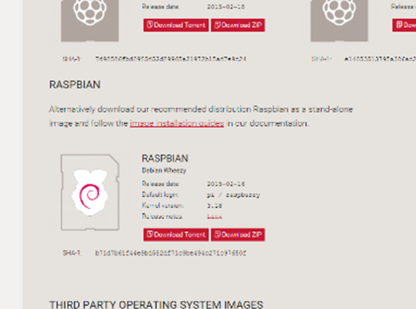

Figure 1B

1. Take the MicroSD card (Figure 1A) and plug it into a computer that has a MicroSD card slot. Alternatively, use a MicroSD to SD card adapter if your computer does not have a MicroSD slot.
2. Go to <https://www.raspberrypi.org/downloads/> and download the ZIP for the latest version of RASPBIAN (Figure 1B).

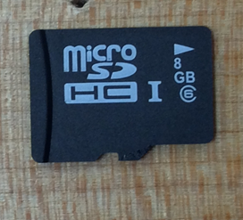

Figure 1A

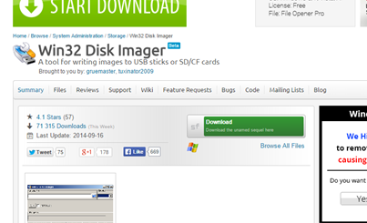

Figure 1C

1. Next, go to <http://sourceforge.net/projects/win32diskimager/> to download Win32DiskImager (Figure 1C). This software is used to place the image of the OS to the MicroSD card.
2. After they are both done downloading, run the installer for Win32DiskImager. Go through the installation process until you get to the end.
3. *Instructions for the rest of OS reloading*

Cable Setup

Figure 2A is a diagram showing every port to plug in wires for things such as mice, keyboards, power, and Ethernet.

1. Attach the included Wi-Fi adapter to one of the USB ports (Figure 2B).
2. Attach your USB keyboard and mouse to 2 of the ports. If you use Bluetooth controllers, then plug them both into the USB port.
3. To connect the Raspberry Pi to your monitor, connect the included HDMI cable (Figure 2F) to the HDMI port on your TV or monitor, and plug the other end into the HDMI port on your Raspberry Pi.
4. If you wish to connect your Raspberry Pi to the network through Ethernet, then plug it into the Ethernet port on the Raspberry Pi. If you wish to use Wi-Fi, then that is explained later in the guide.

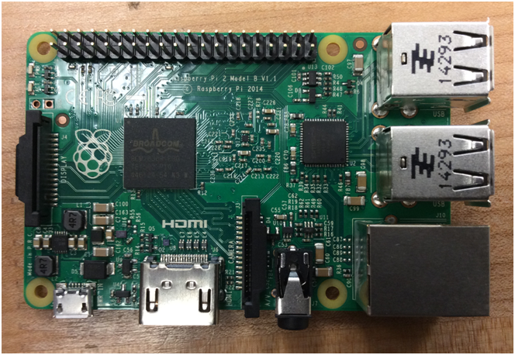

Power

(Micro USB)

HDMI

Camera Slot

Audio/Video Jack

Ethernet Port

USB Ports

Display Slot

Status Lights

Figure 2A

1. Plug your MicroUSB power supply into the power port. You may take power from another USB port from another computer using the included cord, or you may use power from a wall outlet with the adapter. This will start up the Raspberry Pi.

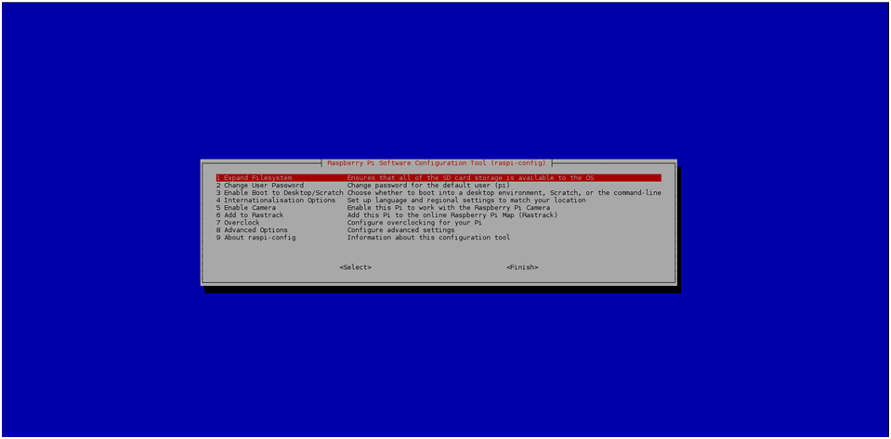

Figure 3A

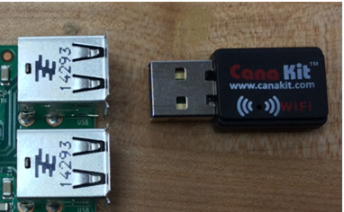

Figure 2B

Initial Boot

Most people will want to access the desktop when they start their Raspberry Pi, so these are the instructions on how to do that. After you finish these instructions, you should immediately go to the desktop after the startup sequence.

1. When you first start up your Raspberry Pi, you will see it go through all of the actions during startup until you reach the configuration screen for it (Figure 3A).
2. To access the desktop, use the up and down arrows on your keyboard along with “Enter” to select option 3. This will bring you to another screen.
3. Select the option which says, “Desktop Log in as user ‘pi’ at the graphical desktop.”
4. You will be automatically returned to the initial menu. Press right until the “Finish” option is highlighted. Select that and select “Yes” to restart your Raspberry Pi.

Wi-Fi Configuration

If you used Ethernet to connect your Raspberry Pi to the Internet, then you can skip this section of the guide. Otherwise, follow these instructions to connect your Raspberry Pi to your Wi-Fi network.

1. While you are at the desktop, use the mouse to click on “Menu” in the top-left corner. Then go to “Preferences” and click on “WiFi Configuration”.
2. If you can’t see your network, you can attempt to connect to it by manually adding it to the list of known networks. To do this, go to the “Network” tab and click on “Add.”
3. In the new window that appears, enter all of your network information (SSID, authentication, password, etc.) and click “Save” when you are finished.
4. Next, go to the “Network” drop down menu and select on the network you added. Then click “Connect”.
5. If something appears next to “IP address:”, then you have successfully connected your Raspberry Pi to the internet.

NOTE: If you are ever disconnected for any reason, just follow step 4 again to reconnect.

Camera Setup

The Raspberry Pi set comes with a camera (Figure 5A). You can use this to take photos or videos and save it to the Raspberry Pi’s memory.

1. Attach the camera to the camera slot by first pulling up the tab on it.

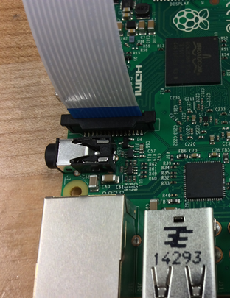

Figure 5B

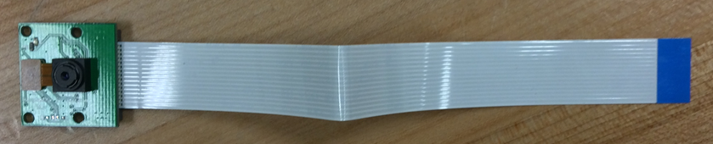

Firgure 5A

1. Plug the camera into it with the plastic blue side facing the Ethernet port (Figure 5B). Push the tab back down to lock it in place.
2. On the desktop, open the terminal emulator by clicking on the icon that looks like a TV with a black screen on the task bar (Figure 5C).
3. Type in the following command: “sudo raspi-config”, and you will be brought back to the configuration screen during the initial boot, but it will be contained within the console emulator.

Figure 5C

Web Browser

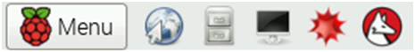

File Browser

Terminal

1. Select option 5, and select “<Enable>” to allow your Raspberry Pi to use the camera.
2. Use right to select “Finish” and restart the Raspberry Pi again.

Taking Photos

The camera that comes with the Raspberry Pi is capable of taking still photos of up to 5 megapixels (2592x1944). It also is capable of autofocus so there is no manual adjustment required. (Figure 6A) is an example photo taken with the camera.

1. Open the terminal again, and you will need to type in a custom command that can be tuned to take different photos.
2. Every command will start with “raspistill” followed by some arguments which change things such as flipping, filename, resolution, and other aspects.
3. Typically, all you will need are 3 arguments to be able to get a good photo.
   1. First, there is the “-o [filename]” argument. This is used to control what the photo is called when it is saved to your Raspberry Pi. If you do not include this argument, it will still look like it is taking a photo and show you what it took, but it will be discarded immediately. For example, if you wanted to save a photo named “cats.jpg”, then the entire command that you would type in is “raspistill -o cats.jpg”. Notice that the “.jpg” is always required at the end of the filename.
   2. The other two arguments are used to flip the photo in both axes, and they would typically be used together, but you may only flip in one axis if you so wish. The arguments are “-vf” and “-hf” to flip the photo vertically and horizontally, respectively. If your camera is upside-down, you can still take rightside-up phots by using the following command: “raspisill -vf -hf”.
   3. Finally, all three arguments can be used at the same time. You should, however, always put the “-o” argument at the end to avoid any confusion. Example: “raspistill -vf -hf -o cats.jpg”.
4. You can find the entire list of arguments at <https://www.raspberrypi.org/documentation/usage/camera/raspicam/raspistill.md>.

Taking Videos

The Raspberry Pi’s camera can take 1080p (1920x1080) videos at 30 frames per second. It can also autofocus during the recording. Keep in mind that there is no way to watch the video after it is finished recording without additional software on the Raspberry Pi.

1. Taking a video is similar to taking a photo with the camera with a few changes. The command used is “raspivid” instead of “raspistill” and the extension must be changed from “.jpg” to “.mp4”.
2. Also, a fourth argument is required. This argument is the “-t [length]” argument and it controls the length of the video in milliseconds (1 second = 1000 milliseconds). For example, “raspivid -t 3000” would take a 3 second video.
3. In total, a command with all 4 arguments would be like the following: “raspivid -vf -hf -t 3000 -o cats.mp4”. This would take a 3-second video flipped in both axes named cats.mp4.

User Management

You can create different users so that if multiple people use the Raspberry Pi, then they can keep their files separate from each other so that there are no conflicts.

1. Creating a New User
   1. Go to the console and type in the following command: “sudo adduser”, followed by the username you with to use. This will be the name that you use to login with. Example: “sudo adduser bob”.
   2. Follow the instructions given to you in the console. You will need to enter your new password for the account, and you can add additional information if needed.
2. Deleting a User
   1. To delete a user, go to the console and type, “sudo deluser”. Note that this time you do not add the username.
   2. It will ask you for the user that you want to delete; type that in.
3. User Permissions
   1. “sudo” Command
      1. You can allow a user to use the “sudo” command. This runs a command as another user. (The entire time you used the sudo command, you have been executing the command as the “root” user, which gives you more privilages.
      2. Go to the console as a user who can use the sudo command (the “pi” user has this by default), and type in the following command: “sudo visudo”.

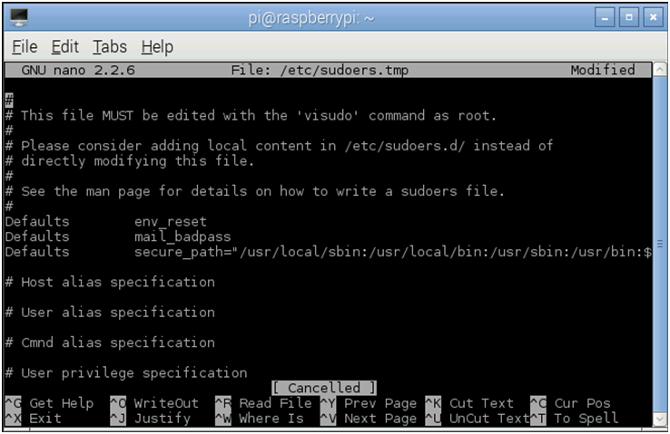

Figure 8A

* + 1. You will be brought to a screen to enter the permissions (Figure 8A) for “sudoers”. Scroll down to the bottom and, under the line that says “pi ALL=(ALL) NOPASSWD: ALL”, type in the same thing, but replace “pi” with the username you wish to grant permissions to.

Customization

There are many different ways you can change the Raspberry Pi. You can change the background color, change the keyboard layout, and do other things.

1. Keyboard Layout
   1. The Raspberry Pi’s default keyboard layout is set to the Great Britain format. You can change this to a different layout. NOTE: These are the instructions for the United States keyboard.
   2. Go to the console and type, “sudo dpkg-reconfigure keyboard-configuration”. This will bring to a screen with a color palate that looks like the initial configuration screen (it will take a while to load).
   3. Find the selection entitled “Generic 105-key (Intl) PC” and select it.
   4. Then, go to the bottom of the next list that pops up and select “Other”.
   5. Find “English (US)” and select it.
   6. Next, scroll back to the top and select “English (US)” again.
   7. Select the option that says, “The default for the keyboard layout”.
   8. Then, select “No compose key”.
   9. Finally, select “<Yes>” to create a shortcut in case the desktop freezes.
   10. You must restart the Raspberry Pi for the changes to take effect.

Installing Arduino

You can attach an Arduino shield to the Raspberry Pi to allow it to be programmed and run all through the Raspberry Pi. You can get it from <http://www.adafruit.com/products/801>.

1. First, you need to install the Arduino IDE, the program used to actually program the Arduino.

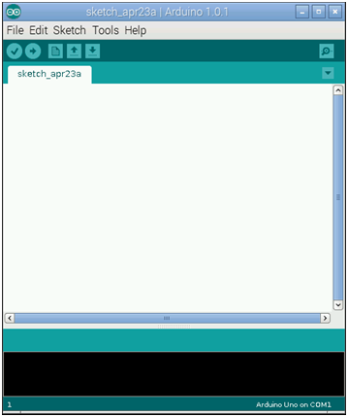

Figure 9A

1. To do this, simply open the terminal again and type in the following command: “sudo apt-get install arduino”. This will go download the program automatically. If there is a message in the terminal asking for confirmation, then just type “y” and press “enter”.
2. To open the program, go to the menu, then “Programming”, then click on “Arduino IDE”. This will bring up a new window (Figure 9A) where you can type the program for the Arduino.

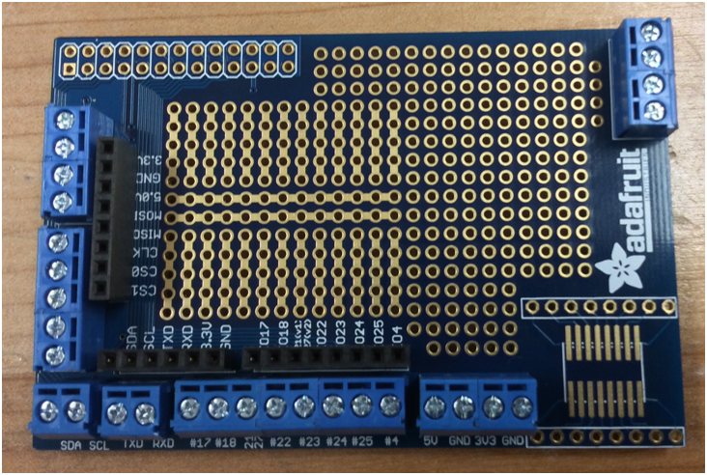

Figure 9B

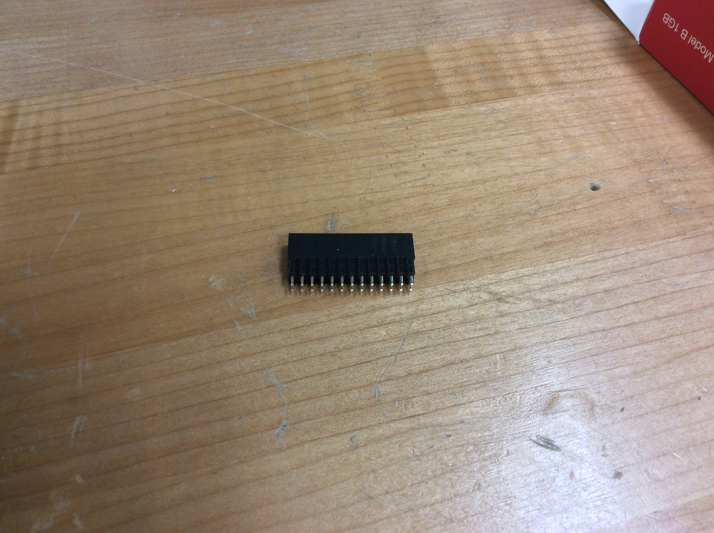

Figure 9C

For the hardware installation, some experience with soldering is required.

1. First, you will need to solder in all of the pieces as arranged in Figure 9B.

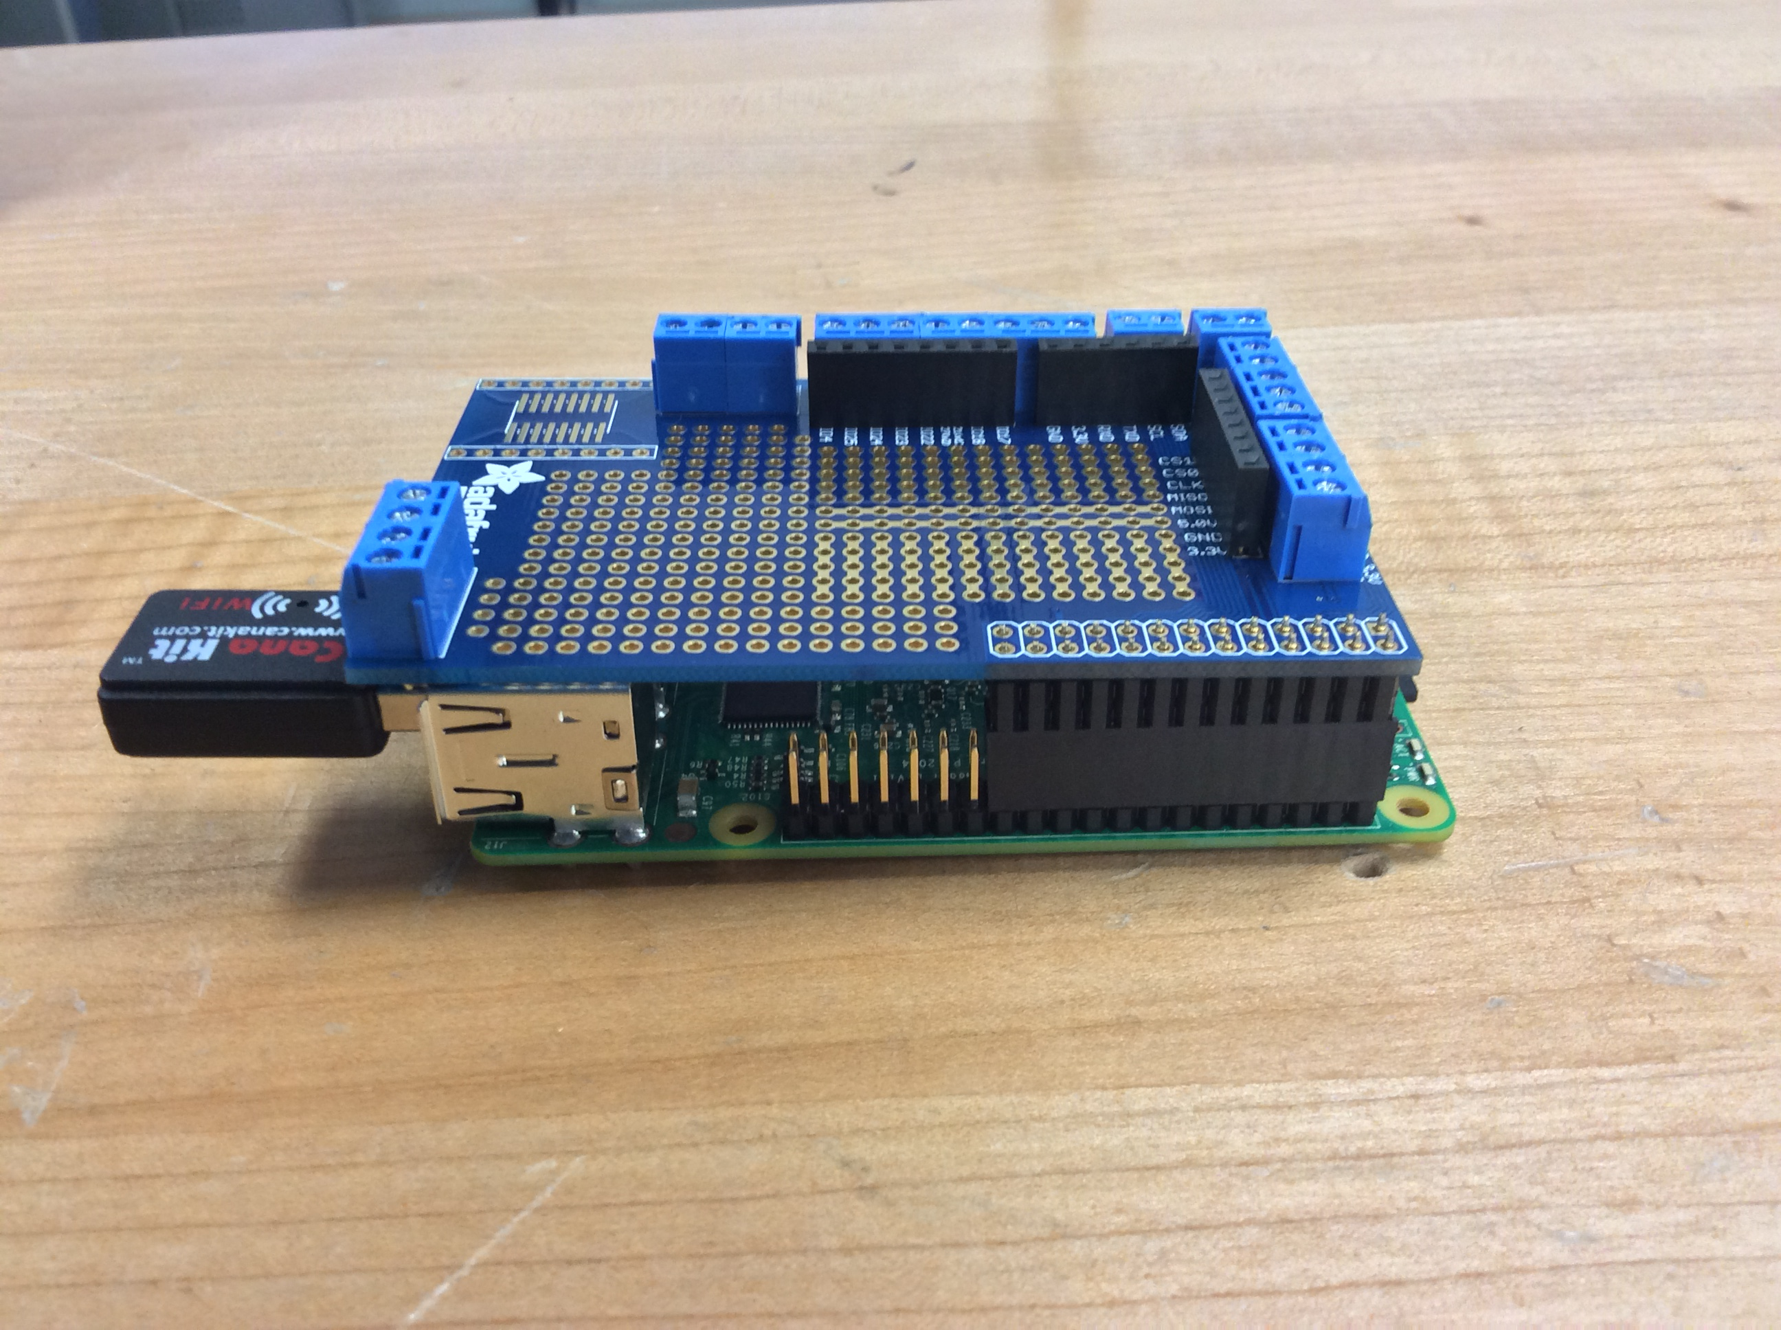

Figure 9D

1. You also want to add the piece shown in Figure 9C to the pins on the Raspberry Pi.
2. Finally, place the Arduino shield on the Raspberry Pi so the pins so it looks like Figure 9D.

You may also want to install a tiny breadboard (<http://www.adafruit.com/products/65>) to work with the other components later. Simply peel the yellow wax paper underneath the breadboard and stick it on the shield (Figure 9E).

Installing the MicroView

MicroView is a small Arduino that will be used to display the data we acquire from it. You can get it from the following website: <https://www.sparkfun.com/products/12923>.

Figure 10A

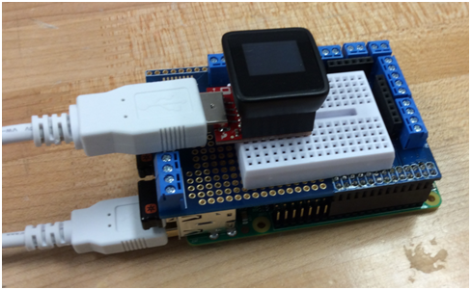

1. Place the MicroView base on the breadboard, the screen on top of the.
2. You also want to plug the USB cable included with the MicroView kit in to one of the USB ports on the Raspberry Pi.
3. It should look like Figure 10A when finished.

Reading the Temperature

You can program the MicroView to read the temperature of its current surroundings using the included temperature sensor. You are also going to need 3 jumper wires.

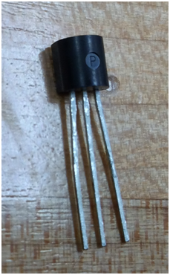

Figure 11A

1. Take the temperature sensor (Figure 11B), and place it somewhere away from the MicroView itself. Make sure the pins are parallel to the white bar in the middle of the breadboard
2. Now, use the 3 jumper wires to link the temperature sensor to the MicroView as shown in Figure 11B.

The software used is available on PasteBin. You will use the Arduino IDE to program the MicroView. You will need the MicroView library.

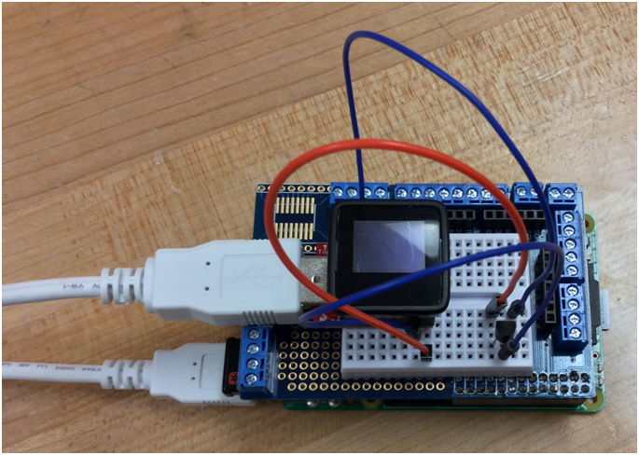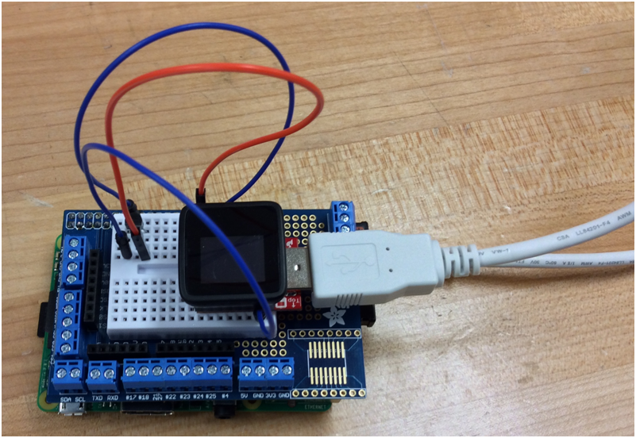

Figure 11B

1. First, go to <https://github.com/geekammo/MicroView-Arduino-Library/archive/master.zip>. This will automatically start a download to get the entire MicroView library.
2. When this is finished, a new window will pop up that shows the contents of the .zip file you downloaded. Go to the “Action” tab and click “Extract”.
3. Click “Extract” again on the new windows to extract the folder.
4. Next, you will need to rename the folder so it just says “MicroView”. Right click on the folder and click “Rename”.
5. Since the permissions on the default user don’t allow you to make changes to the root folder, you will need to use console commands to move the folder. The command you will need to run is the following: “sudo mv Downloads/MicroView /usr/share/arduino/libraries”. This will move the renamed folder to the “libraries” folder in the Arduino IDE.
6. Open up the Arduino IDE. Go to the “Sketch” tab, mouse over “Import Library”, and click on “MicroView”. If this doesn’t show up, then redo steps 2-5.

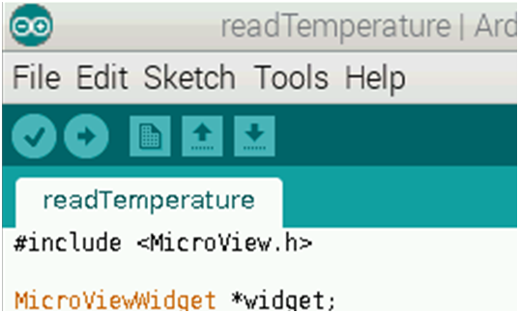

Figure 11C

1. Delete the new “#include” lines on the code so the sketch is empty again.
2. Go to <http://pastebin.com/iDPFN7Ma> and copy all of the code there.
3. Open your Arduino IDE and paste the code into it.
4. Mouse over “Serial Port”, and click on “/dev/ttyUSB#” with the “#” being any number from 0-3. If you see it, click it.
5. Finally, upload the program to the MicroView by clicking on the button that looks like an arrow (Figure 11C).

Reading the Temperature

Assuming you did everything correctly, you should be able to see the temperature and/or write the temperatures to the file through just the terminal.

1. Output temperature to terminal
   1. You will need to install another piece of software. Use following command: “sudo apt-get install ttylog”.
   2. Once you have finished the installation, just type “ttylog -b 57600 -d /dev/ttylogUSB#” with # being the serial port you selected earlier.
   3. The terminal should start outputting the temperature in Fahrenheit to the console every second.
2. Output temperature to text file
   1. Complete steps a-b in the “Output temperature to terminal” section.
   2. The command you will use is “ttylog -b 57600 -d /dev/ttylogUSB# > temperature.txt”. This will output the temperature to the text file instead of directly to the console. NOTE: The temperature will NOT output to the console any more